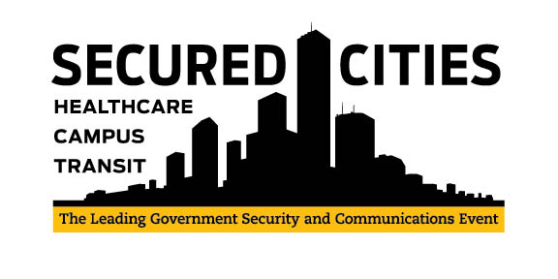

Secured Cities Letter of Justification

Dear _____________________,

As a government official charged with staying current with the latest in technology and trends related to interoperability, agency efficiency, safety and best practices, I would like to attend Secured Cities event in Houston, TX, November 15 – 17, 2016.

Registration for the Secured Cities conference and trade show is affordable with early bird pricing rates beginning at $199 and includes all educational sessions, lunches and breakfasts, two networking receptions, a venue tour and keynote presentations.

I want to attend Secured Cities because:
- It is the best conference in the country related to interoperability, public safety, and emergency management, emerging security technologies and public/private partnerships. There is no better place to exchange ideas with colleagues and determine best practices.
- I can source, see and learn more about video surveillance, wireless technology, Physical Security Information Management, video analytics, communications solutions and other interoperable products and services all in one venue.
- I can network with department and agency leads responsible for interoperability and technology from more jurisdictions from around the country.
- Houston is hosting the NFL’s Super Bowl in 2017 and therefore is aggressively preparing itself to secure its city from any unplanned threats.
- The Crowne Plaza hotel is affordable at only $111 per night

While in attendance, I will focus my training on education that will benefit our service. Specifically, I plan to participate in the following sessions:

1)_____________________________ 2)_____________________________

3) _____________________________ 4) _____________________________

I also plan on visiting the following exhibitors in hopes of saving money, increasing efficiency and providing ideas on what new technology will help us keep our citizens safer:

1)_____________________________ 2)_____________________________

3)_____________________________ 4)_____________________________

In addition to the above, when I get back I will be able to multiply the benefit by sharing all of the information and training with you and other members of the team.

Thank you for considering my request to attend Secured Cities and I look forward to your reply.

Regards,

____________________________

